Chapter 5, Solution 33.

Refer to the op amp circuit in Fig. 5.71. Calculate i_{x} and the power absorbed by the 3-kΩ resistor.
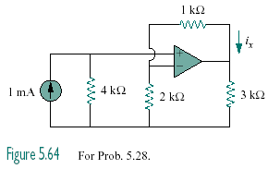

Figure 5.71
For Prob. 5.33.

Solution

After transforming the current source, the circuit is as shown below:

4 kΩ

2 kΩ

4 V

+
−
+
−

1 kΩ

v_{o}

v_{a}

v_{i}

3 kΩ

This is a noninverting amplifier.

Since the current entering the op amp is 0, the source resistor has a 0 V potential drop. Hence v_{i} = 4V.

Power dissipated by the 3kΩ resistor is

12mW

–2mA.

12 mW, –2 mA

